COS20019
Cloud Computing Architechture
Truong Ngoc Gia Hieu
105565520
Week 4 – ACF Lab 4:
Working with EBS
Lab 4: Working with EBS
A. Lab Overview
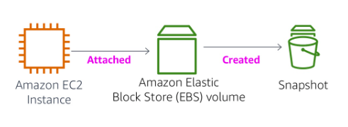

This lab focuses on Amazon Elastic Block Store (Amazon EBS), a key underlying storage mechanism for Amazon EC2 instances. In this lab, you will learn how to create an Amazon EBS volume, attach it to an instance, apply a file system to the volume, and then take a snapshot backup.

Topics covered
By the end of this lab, you will be able to:
- Create an Amazon EBS volume
- Attach and mount your volume to an EC2 instance
- Create a snapshot of your volume
- Create a new volume from your snapshot
- Attach and mount the new volume to your EC2 instance

Duration
This lab will require approximately 30 minutes to complete.

AWS service restrictions
In this lab environment, access to AWS services and service actions might be restricted to the ones that are needed to complete the lab instructions. You might encounter errors if you attempt to access other services or perform actions beyond the ones that are described in this lab.

What is Amazon Elastic Block Store?
Amazon Elastic Block Store (Amazon EBS) offers persistent storage for Amazon EC2 instances. Amazon EBS volumes are network-attached and persist independently from the life of an instance. Amazon EBS volumes are highly available, highly reliable volumes that can be leveraged as an Amazon EC2 instances boot partition or attached to a running Amazon EC2 instance as a standard block device.
When used as a boot partition, Amazon EC2 instances can be stopped and subsequently restarted, enabling you to pay only for the storage resources used while maintaining your instance's state. Amazon EBS volumes offer greatly improved durability over local Amazon EC2 instance stores because Amazon EBS volumes are automatically replicated on the backend (in a single Availability Zone).
For those wanting even more durability, Amazon EBS provides the ability to create point-in-time consistent snapshots of your volumes that are then stored in Amazon Simple Storage Service (Amazon S3) and automatically replicated across multiple Availability Zones. These snapshots can be used as the starting point for new Amazon EBS volumes and can protect your data for long-term durability. You can also easily share these snapshots with co-workers and other AWS developers.
This lab guide explains basic concepts of Amazon EBS in a step-by-step fashion. However, it can only give a brief overview of Amazon EBS concepts. For further information, see the Amazon EBS documentation.

Amazon EBS Volume Features
Amazon EBS volumes deliver the following features:
- Persistent storage: Volume lifetime is independent of any particular Amazon EC2 instance.
- General purpose: Amazon EBS volumes are raw, unformatted block devices that can be used from any operating system.
- High performance: Amazon EBS volumes are equal to or better than local Amazon EC2 drives.
- High reliability: Amazon EBS volumes have built-in redundancy within an Availability Zone.
- Designed for resiliency: The AFR (Annual Failure Rate) of Amazon EBS is between 0.1% and 1%.
- Variable size: Volume sizes range from 1 GB to 16 TB.
- Easy to use: Amazon EBS volumes can be easily created, attached, backed up, restored, and deleted.

Accessing the AWS Management Console
1. At the top of these instructions, choose Start Lab.
- The lab session starts.
- A timer displays at the top of the page and shows the time remaining in the session.
Tip: To refresh the session length at any time, choose Start Lab again before the timer reaches 0:00.
- Before you continue, wait until the circle icon to the right of the AWS link in the upper-left corner turns green.

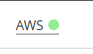

Figure 1: AWS Link activated
2. To connect to the AWS Management Console, choose the AWS link in the upper-left corner.
- A new browser tab opens and connects you to the console.
Tip: If a new browser tab does not open, a banner or icon is usually at the top of your browser with the message that your browser is preventing the site from opening pop-up windows. Choose the banner or icon, and then choose Allow pop-ups.

3. Arrange the AWS Management Console tab so that it displays along side these instructions. Ideally, you will be able to see both browser tabs at the same time, to make it easier to follow the lab steps.

Getting Credit for your work
At the end of this lab you will be instructed to submit the lab to receive a score based on your progress.
Tip: The script that checks you works may only award points if you name resources and set configurations as specified. In particular, values in these instructions that appear in This Format should be entered exactly as documented (case-sensitive).

B. Task 1: Create a New EBS Volume
In this task, you will create and attach an Amazon EBS volume to a new Amazon EC2 instance
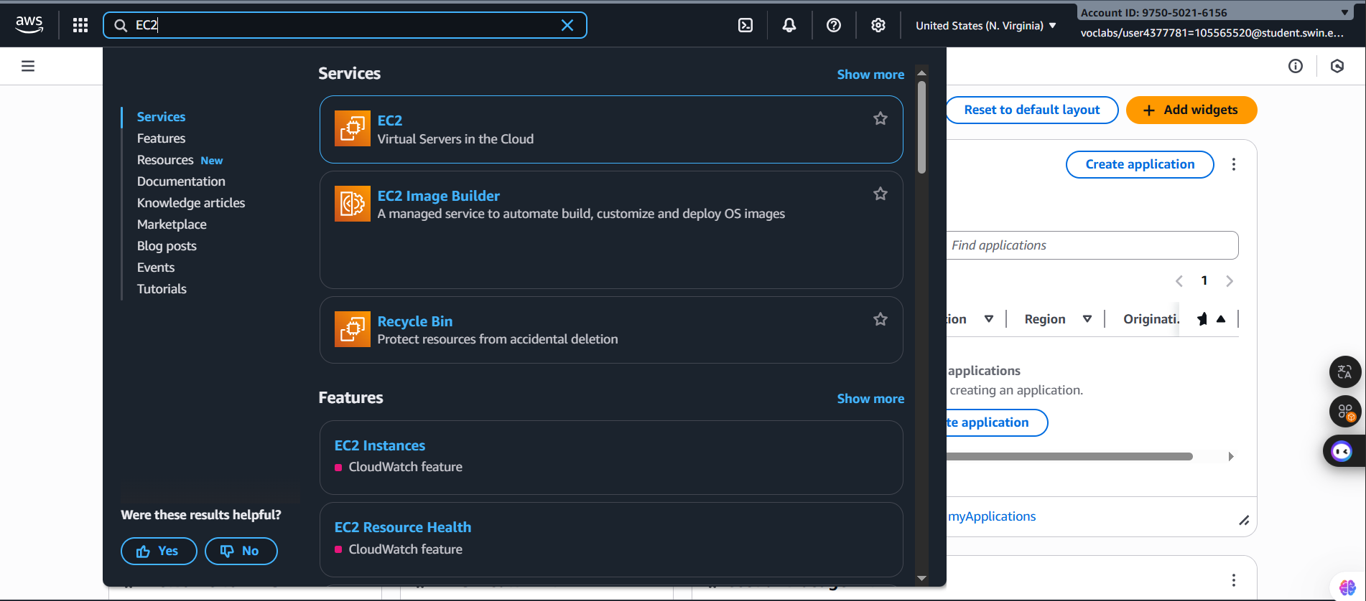
4. In the AWS Management Console, in the search box next to , search for and select EC2.
Figure 2: Searching for EC2

5. In the left navigation pane, choose Instances.
An Amazon EC2 instance named Lab has already been launched for your lab.
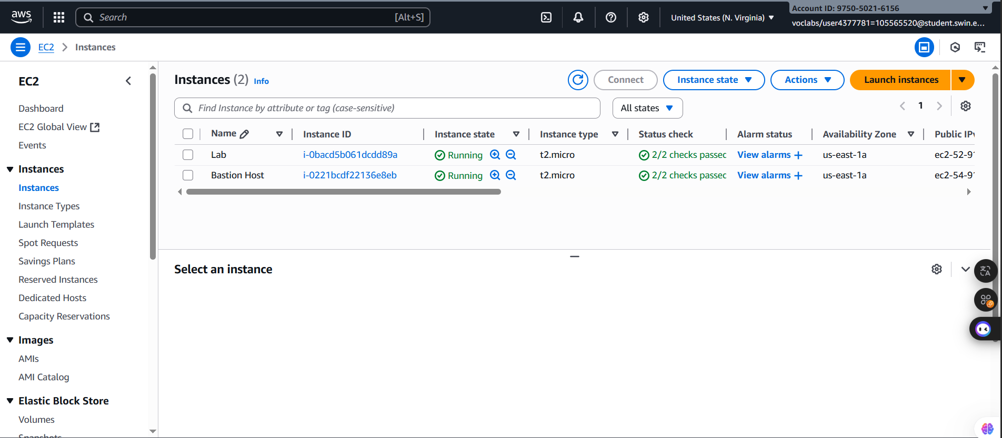
Figure 3: Instances page in EC2

6. Note the Availability Zone of the instance. It will look similar to us-east-1a.

7. In the left navigation pane, choose Volumes.
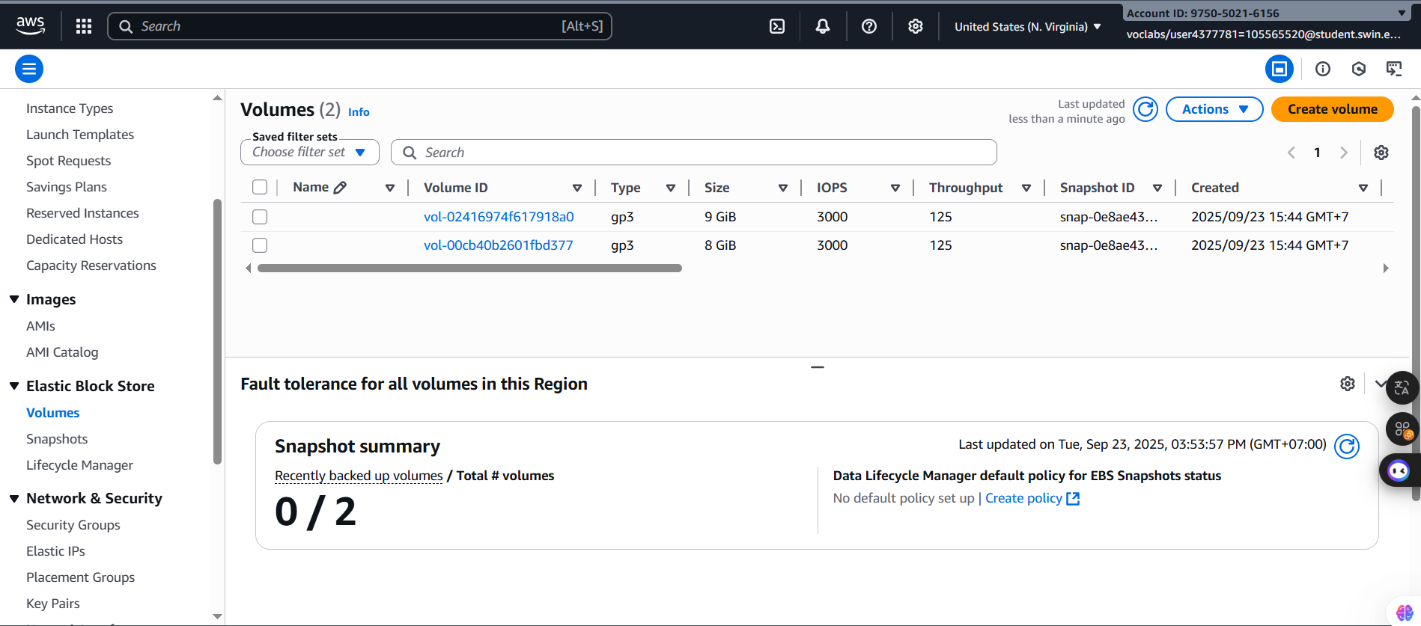
You will see an existing volume that is being used by the Amazon EC2 instance. This volume has a size of 8 GiB, which makes it easy to distinguish from the volume you will create next, which will be 1 GiB in size.
Figure 4: Volumes page n EC2

8. Choose then configure:
- Volume Type: General Purpose SSD (gp2)
- Size (GiB): 1. NOTE: You may be restricted from creating large volumes.
- Availability Zone: Select the same availability zone as your EC2 instance.
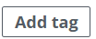
- Choose
- In the Tag Editor, enter:
- Key: Name
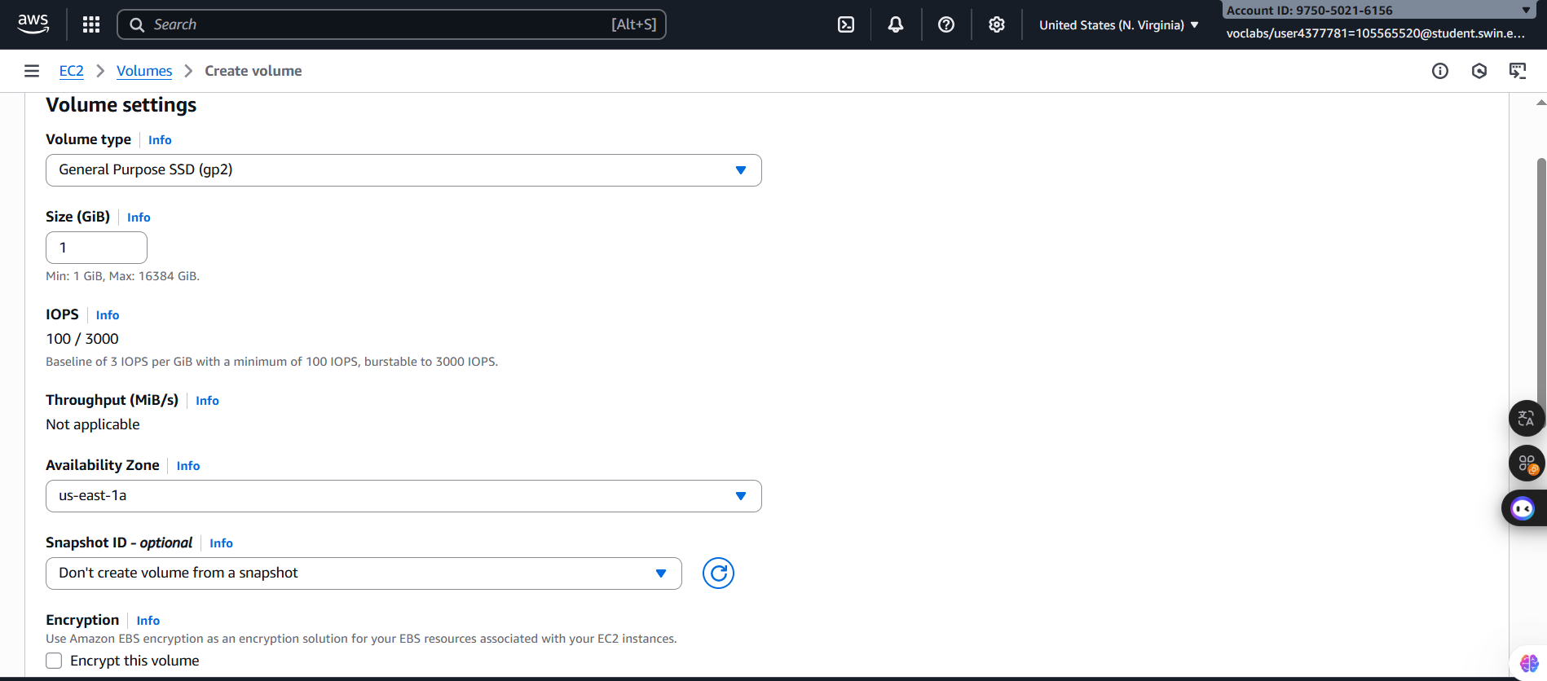
- Value: My Volume

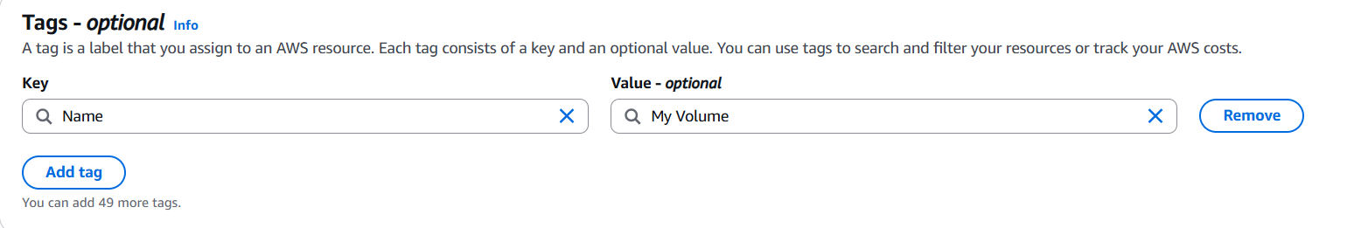
Figure 5: Volume settings configuration

Figure 6: Tag configuration

9. Choose
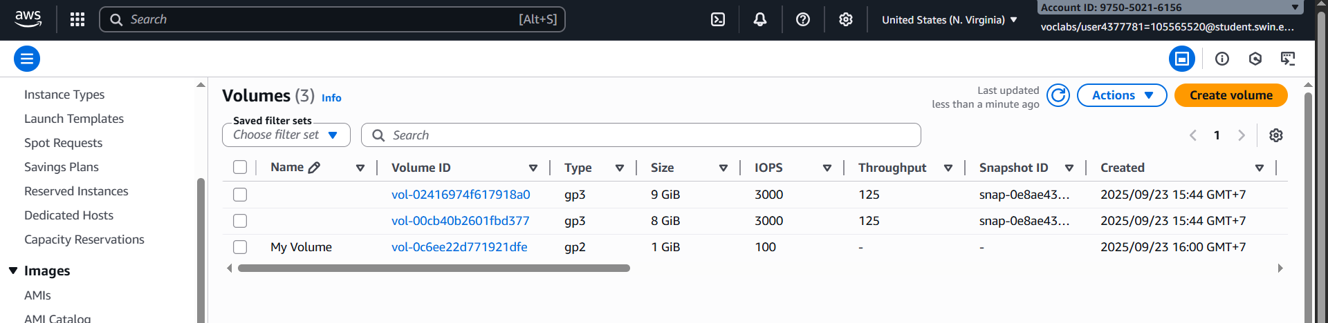
Your new volume will appear in the list, and will move from the Creating state to the Available state. You may need to choose refresh to see your new volume.
Figure 7: Volume created successfully

C. Task 2: Attach the Volume to an Instance
In this task you will attach the new EBS volume to the Amazon EC2 instance.
10. Select My Volume.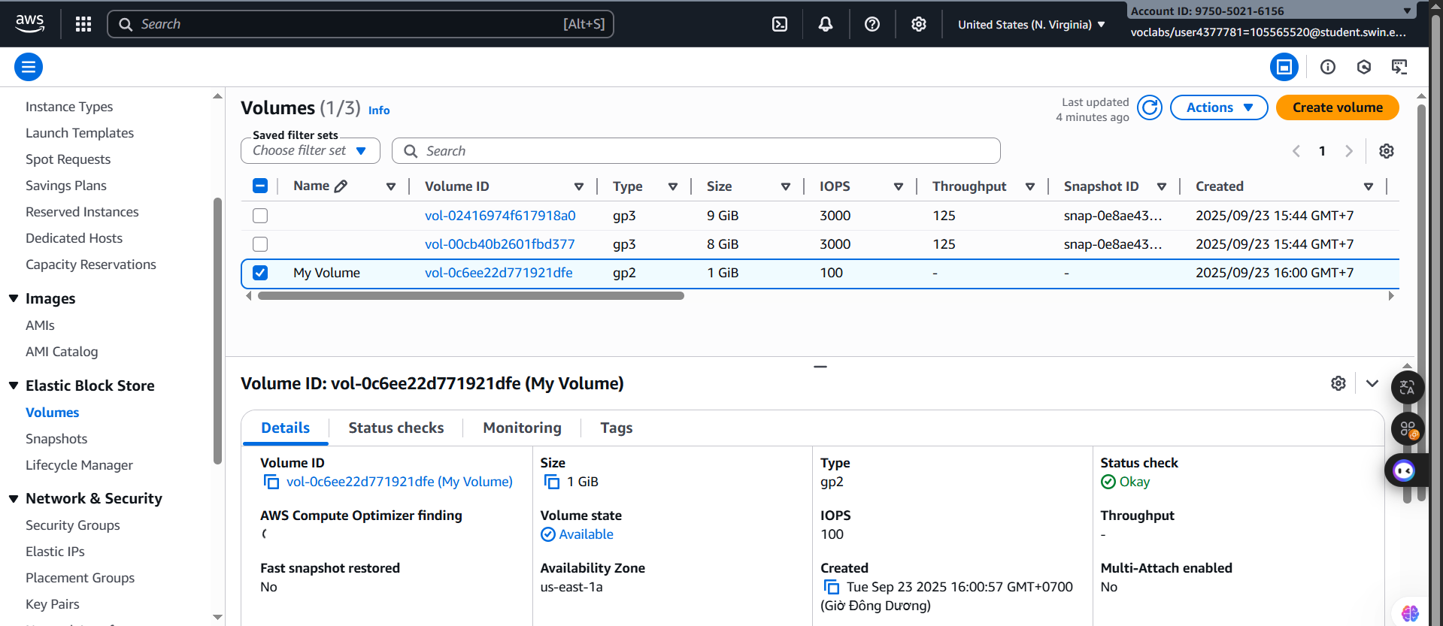
Figure 8: MyVolume selected

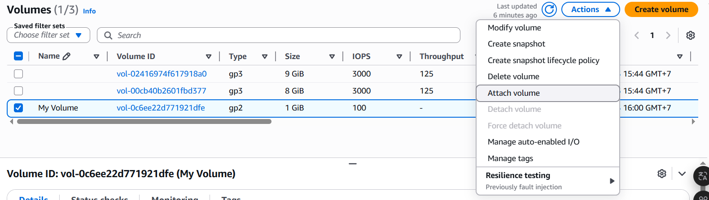
11. In the Actions menu, choose Attach volume.

Figure 9: Attach Volume selected

12. Choose the Instance field, then select the Lab instance.
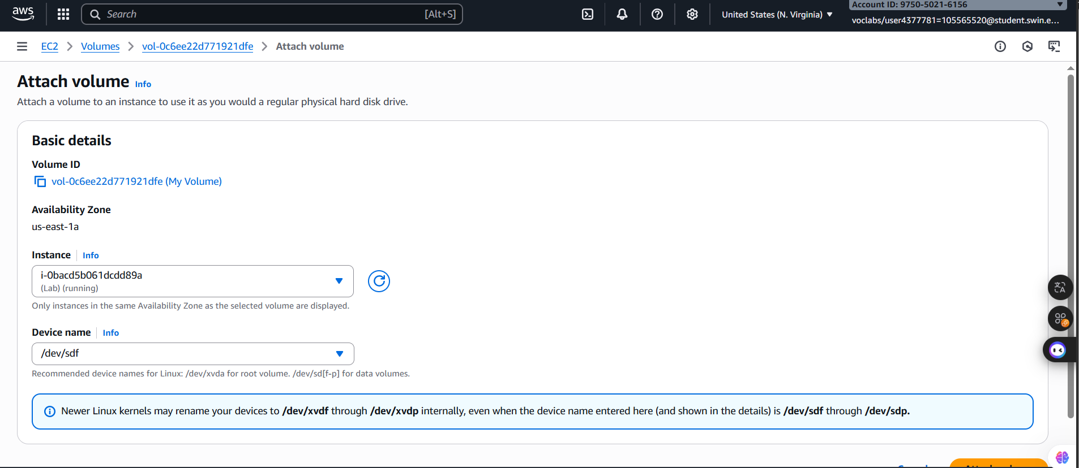
Note that the Device name is set to /dev/sdf. Notice also the message displayed that "Newer Linux kernels may rename your devices to /dev/xvdf through /dev/xvdp internally, even when the device name entered here (and shown in the details) is /dev/sdf through /dev/sdp."
Figure 10: Attach volume configuration

13. Choose
The volume state is now In-use.

D. Task 3: Connect to Your Amazon EC2 Instance
In this task, you will connect to the EC2 instance using EC2 Instance Connect which provides access to a terminal in the browser.
14. In the AWS Management Console, in the search box next to , search for and select EC2.

15. Choose Instances.

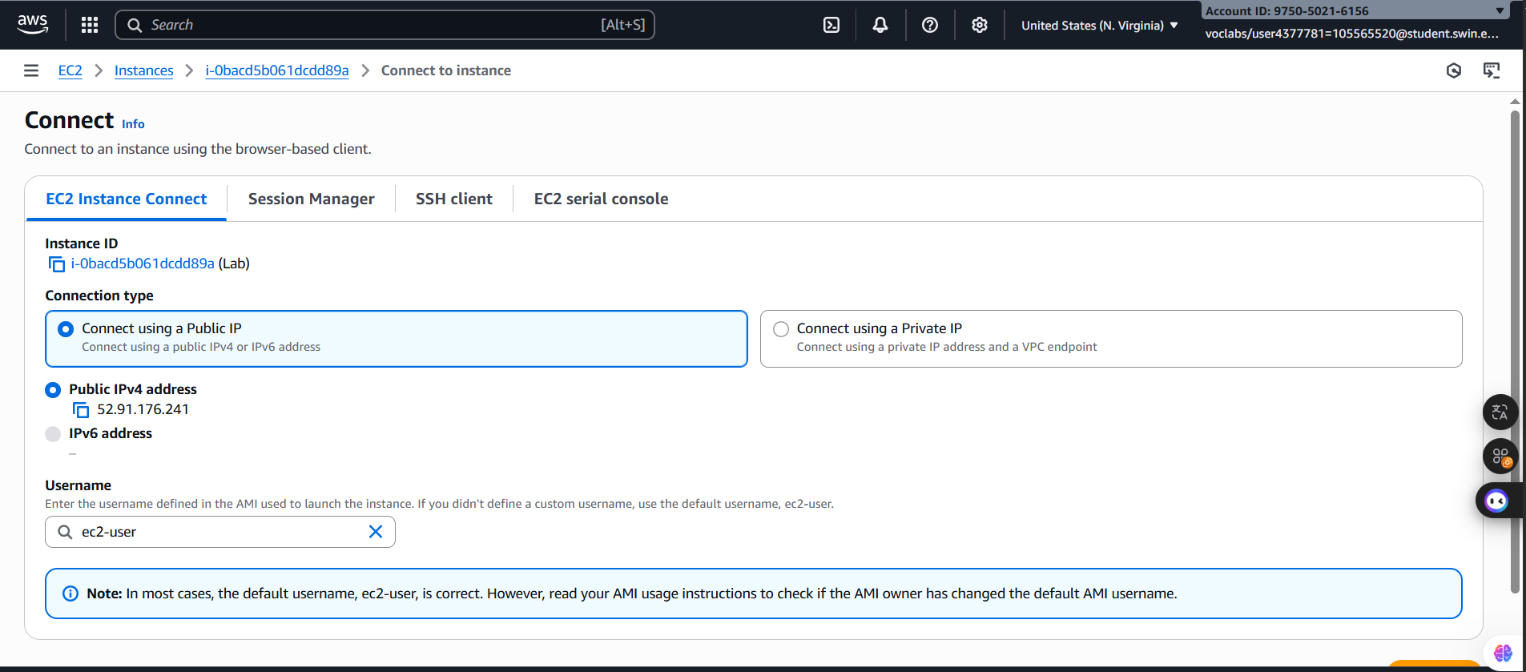
16. Select the Lab instance, and then choose Connect.
Figure 11: Connect configuration
17. On the EC2 Instance Connect tab, choose Connect.
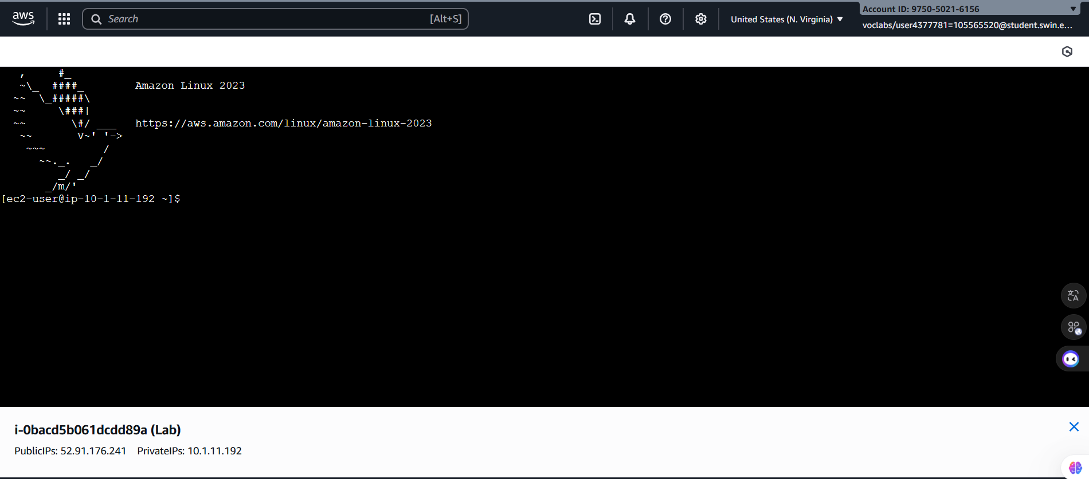
An EC2 Instance Connect terminal session opens and displays a $ prompt.
Figure 12: Connect page

E. Task 4: Create and Configure Your File System
In this task, you will add the new volume to a Linux instance as an ext3 file system under the /mnt/data-store mount point.
18. View the storage available on your instance:
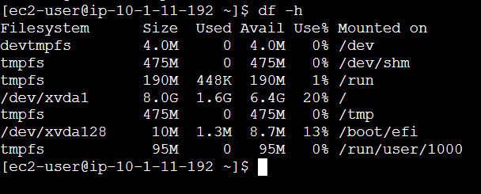
Run the following command:
Figure 13: “df -h” command result

19. Create an ext3 file system on the new volume:

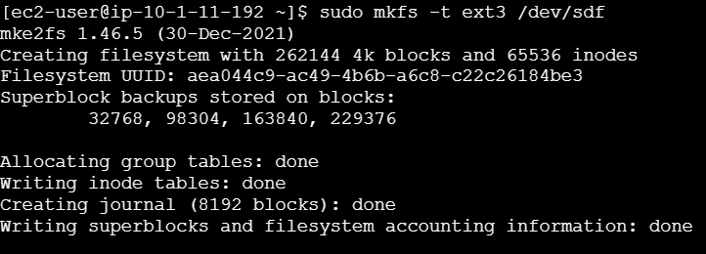
Figure 14: “sudo mkfs -t ext3 /dev/sdf” command result

20. Create a directory for mounting the new storage volume:
Figure 15: “sudo mkdir /mnt/data-store” command result

21. Mount the new volume:
Figure 16: Mount new volume line

22. View the configuration file to see the setting on the last line:
Figure 17: “cat /etc/fstab” command line

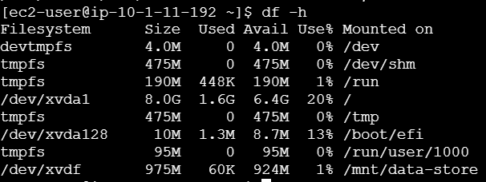
23. View the available storage again:

Figure 18: “df -h” command line

24. On your mounted volume, create a file and add some text to it.
25. Verify that the text has been written to your volume.
F. Task 5: Create an Amazon EBS Snapshot
In this task, you will create a snapshot of your EBS volume.

You can create any number of point-in-time, consistent snapshots from Amazon EBS volumes at any time. Amazon EBS snapshots are stored in Amazon S3 with high durability. New Amazon EBS volumes can be created out of snapshots for cloning or restoring backups. Amazon EBS snapshots can also be easily shared among AWS users or copied over AWS regions.

26. In the EC2 Console, choose Volumes and select My Volume.
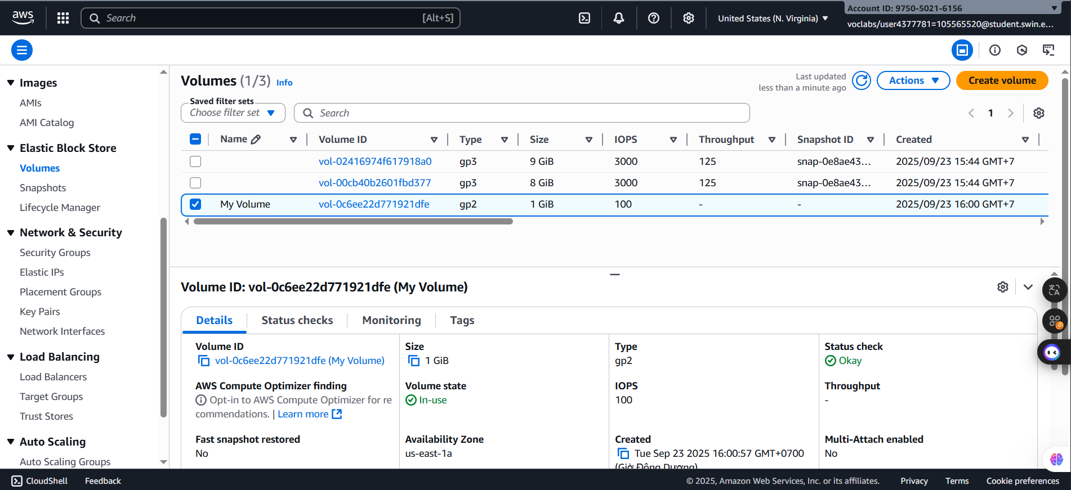

Figure 19: MyVolume selected

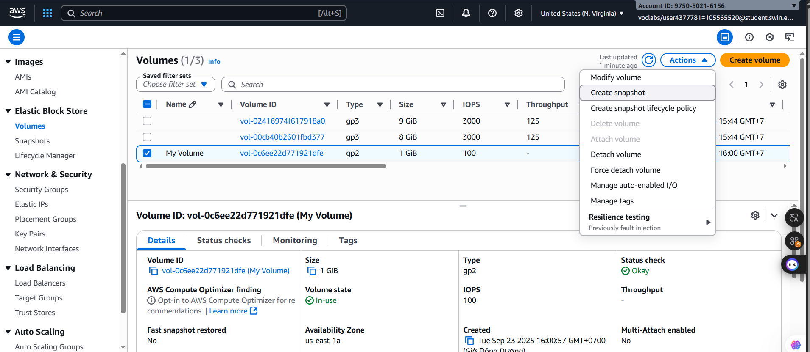
27. In the Actions menu, select Create snapshot.

Figure 20: “Create Snapshot” selected
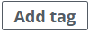
28. Choose then configure:
  - Key: Name
  - Value: My Snapshot
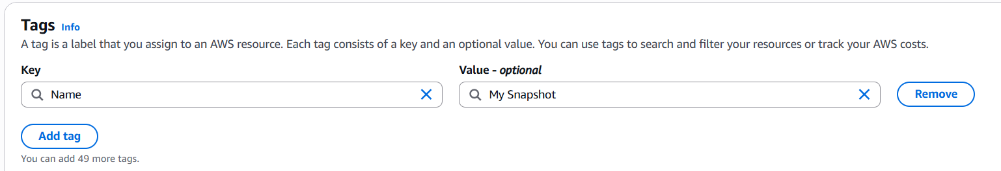

  - Choose
Figure 21: Tags configuration
29. In the left navigation pane, choose Snapshots.
Your snapshot is displayed. The status will first have a state of Pending, which means that the snapshot is being created. It will then change to a state of Completed.
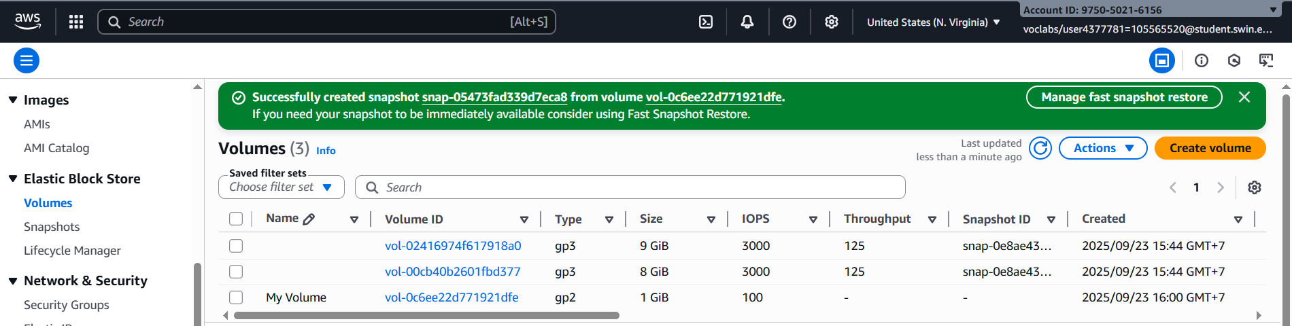
Note: Only used storage blocks are copied to snapshots, so empty blocks do not occupy any snapshot storage space.

Figure 22: Snapshots created successfully

30. In your EC2 Instance Connect session, delete the file that you created on your volume.

31. Verify that the file has been deleted.

G. Task 6: Restore the Amazon EBS Snapshot
If you ever wish to retrieve data stored in a snapshot, you can Restore the snapshot to a new EBS volume.
6.1 Create a Volume Using Your Snapshot
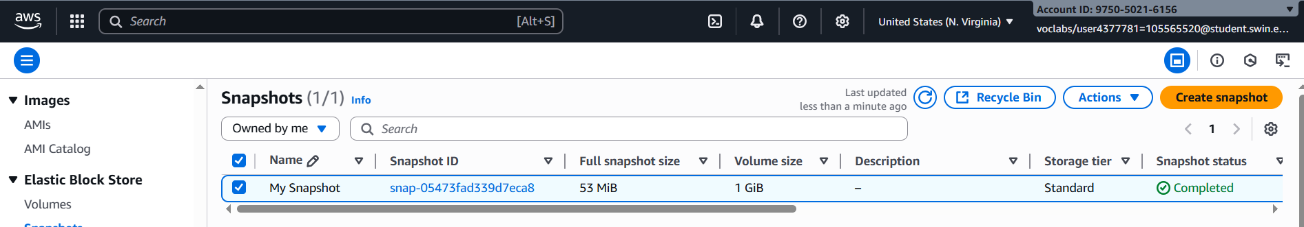
32. In the EC2 console, select My Snapshot.
Figure 23: My Snapshot selected

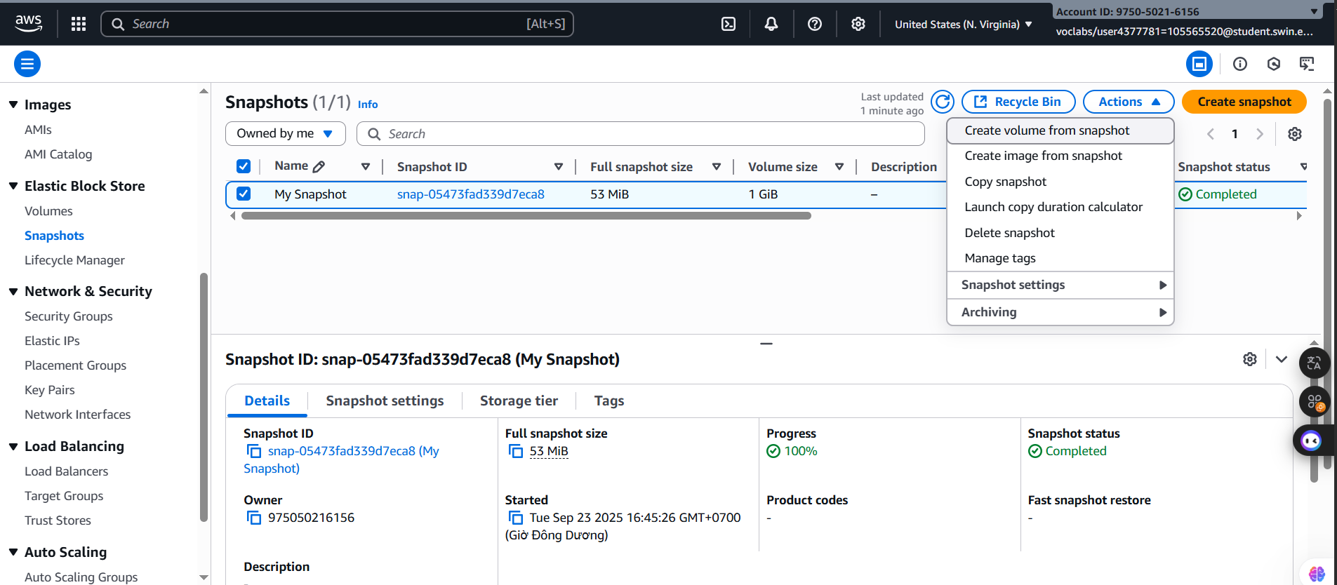
33. In the Actions menu, select Create volume from snapshot.
Figure 24: “Create volume from snapshot” selection

34. For Availability Zone, select the same availability zone that you used earlier.
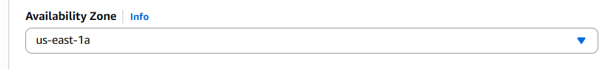
Figure 25: Availability Zone seletcion
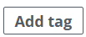
35. Choose then configure:
- Key: Name
- Restored: Volume
- Choose Create volume
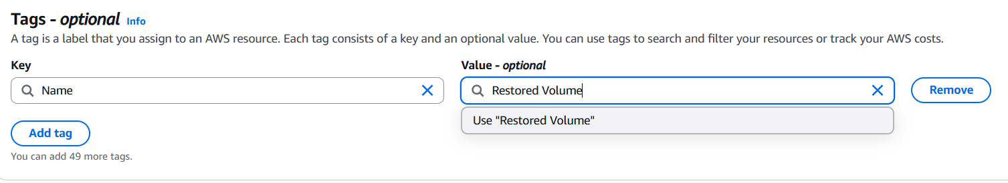
Note: When restoring a snapshot to a new volume, you can also modify the configuration, such as changing the volume type, size or Availability Zone.
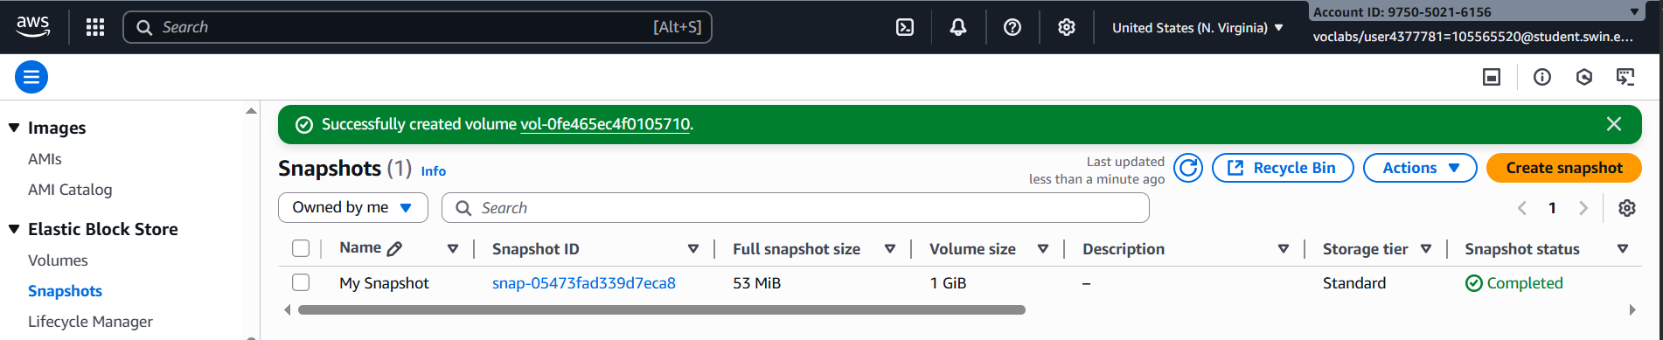
Figure 26: Tag configuration
Figure 26: Successfully configuration
6.2 Attach the Restored Volume to Your EC2 Instance
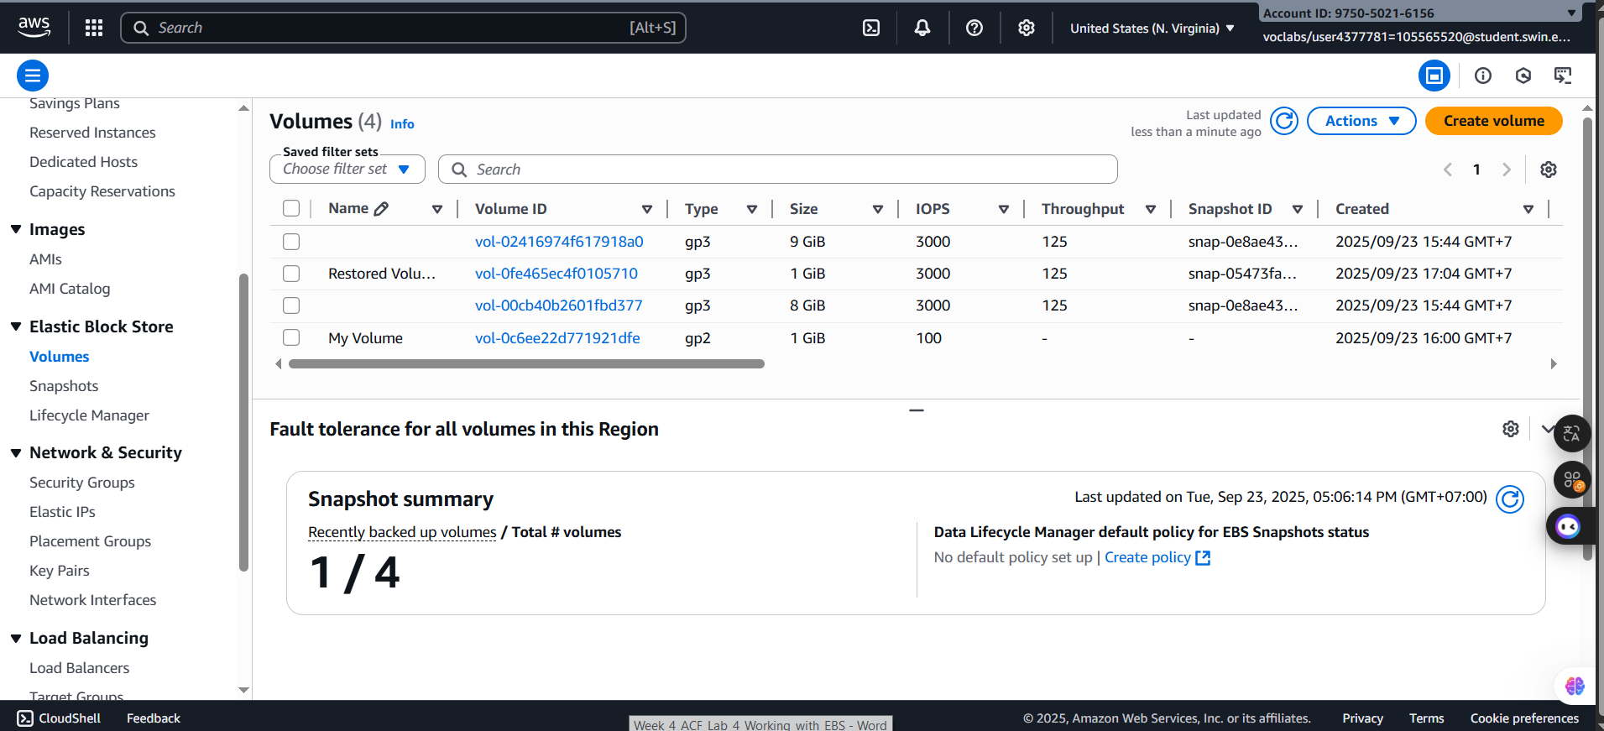
36. In the left navigation pane, choose Volumes.
Figure 27: Volume main homepage
37. Select Restored Volume.

38. Choose the Instance field, then select the Lab instance that appears.
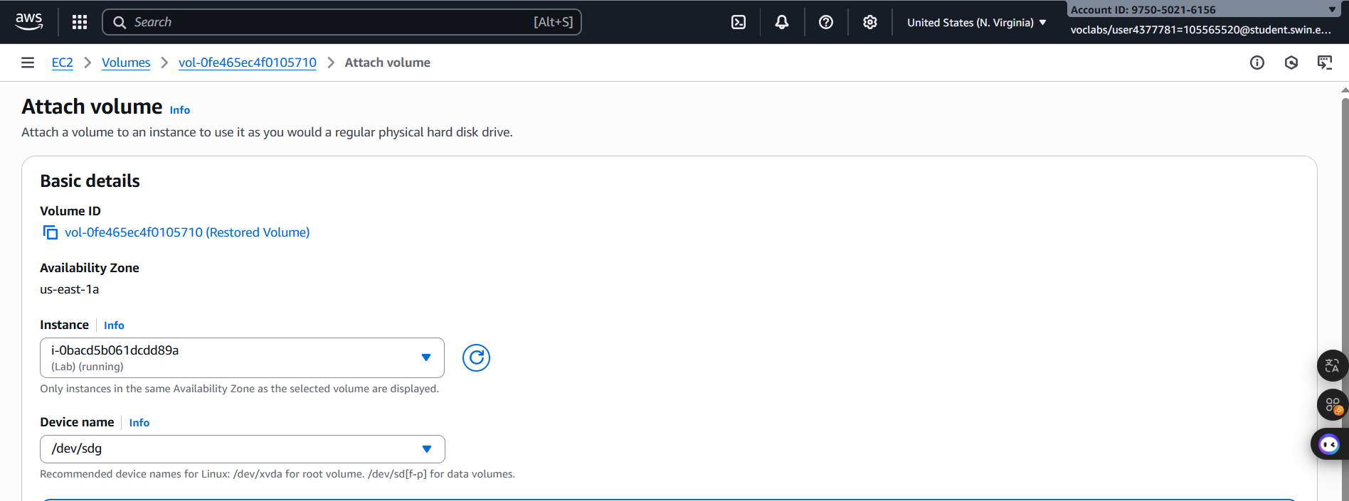
Note that the Device field is set to /dev/sdg. You will use this device identifier in a later task
Figure 28: Attah volume configuration
40. Choose
The volume state is now in-use.

6.3 Mount the Restored Volume
41. Create a directory for mounting the new storage volume:

42. Mount the new volume:

43. Verify that volume you mounted has the file that you created earlier.

H. Submitting your work
44. To record your progress, choose Submit at the top of these instructions.

45. When prompted, choose Yes.
After a couple of minutes, the grades panel appears and shows you how many points you earned for each task. If the results don't display after a couple of minutes, choose Grades at the top of these instructions.
Tip: You can submit your work multiple times. After you change your work, choose Submit again. Your last submission is recorded for this lab.

46. To find detailed feedback about your work, choose Submission Report.
Tip: For any checks where you did not receive full points, there are sometimes helpful details provided in the submission report.
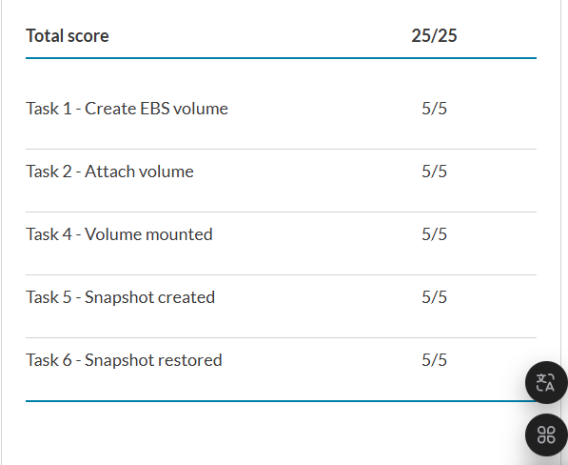
Figure 29: Lab Completed
I. Conclusion
- The lab provides practical experience in working with Amazon Elastic Block Store (EBS) and its integration with Amazon EC2 instances. During the step-by-step tasks, I successfully created and attached an EBS volume, formatted it with a file system, and mounted it for use. Then, I performed snapshot operations to back up and restore data, demonstrating how EBS snapshots ensure data durability and recovery across availability zones.

- By completing these tasks, I gained a better understanding of how persistent storage works in AWS and why EBS is more reliable than instance storage. I also saw how easy it is to back up and restore data using snapshots, which is an important skill for maintaining durability and availability in cloud environments. Overall, this lab helped me build confidence in managing storage resources on AWS.

